Public Archives Branch (HRB) Boxes:
Detached lid
Acid-free
Lignin-free High Alpha Cellulose Board
Both Liners and Medium
B-Flute
pH 8.5+/-.5 with 3% Calcium Carbonate Buffering
Alkaline Sizing
No Alum Rosin Sizing
Color Fast
Triple Thickness Ends
Double Thickness Bottom
Double Layered Sides
No Glued or Stapled Seams
Shipped flat with fold lines scored
Dimensions:
Exterior with lid - 17 1/16” long x 6 ¼” wide x 10 3/8” high
Interior - 15 3/8” long x 6 1/8” wide x 9 7/8” high
Graphics on box:

- Left long side – logo aligned to the right bottom corner, 1” from the 3 sides (FIG. 1)
- Left long side – text to be centered from the left side of logo, and 2” from bottom (FIG. 1)
- Short side (one) – text to be 2” below opening, centered (FIG. 2)
- Short side (one) – outline of a box, with two lines drawn as pictured (5x6”), centered from text to bottom and left to right (FIG. 2)

See illustration below:

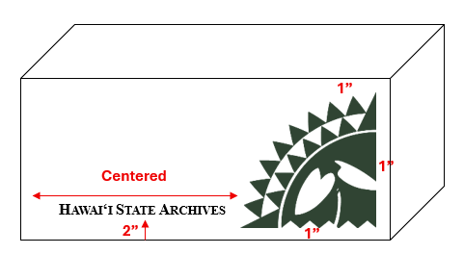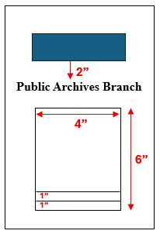
FIG. 1
FIG. 2

